No. of Pages | 4
No. of Questions | 8

Department of Computer Science and Engineering
Final Examination Spring 2010

CSE260: Digital Logic Design
Total Marks: 120 Time Allowed: 3 Hour

- Answer ALL questions

Question No. 1

- Convert (101 0110 1100 1101 1110 . 1100 10)₂ to its hexadecimal equivalent.
- Write down the range of a 12 bit 2’s complement number system.
- Assume you have an 8 bit 2’s complement numbering system. Express -32 and 125 in this binary system.
- Using 2’s complement method of subtraction, find the result of subtracting -32 from 125. State whether the result of your answer is an overflow or not, with appropriate justification.
(20 marks)

Question No. 2

- Determine whether the statement “W.X + Y’ + Z = (W + Y’ + Z).(X + Y’ + W’.Z + W.Z)” is true or false using truth table.

- Give the truth table for the binary full adder, and show a possible implementation. (You can use any gates or MSI blocks of your choice.)

- Implement the truth table given below using a
- A 3-to-8 decoder.
ii) 8-to-1 multiplexer.

A B C | f
0 0 0 | 1
0 0 1 | 0
0 1 0 | 0
0 1 1 | X
1 0 0 | 1
1 0 1 | 1
1 1 0 | X
1 1 1 | 0

(20 marks)

Question No. 3

A digital circuit takes in a 4 bit number, and converts it to a number which is 3 greater than the input number. In case of overflow, the count is restarted from zero. (e.g. 3 becomes 6, 12 becomes 15, 13 becomes 0 and so on …)

- Construct the truth table for the above system.

- Using only encoders and decoders, design a circuit that would perform the above function.

(10 marks)

Question No. 4

- Draw circuit diagrams for creating AND, OR and NOT gates using 4x1 MUXs.

- Draw circuit diagrams to show that NAND gates can be used to create AND, OR and NOT gates.
- A function F(w, x, y, z) = ∑ (1,4,6,7,8,9,10,11,15). Use the Quine-McCluskey method (the tabulation method) to determine the minimized function and show the circuit implementation of the function.
(20 marks)

Question No. 5

- Draw the block diagram of a single memory cell of static RAM.

- Using the block diagram in part (a), and other appropriate MSI blocks, show the logical construction of an 8 X 5 RAM with appropriate input and output lines.
(10 marks)

Question No. 6

- Draw the circuit diagram for a 4-bit shift register using D Flip Flops which will have 2 selection pins and whose behavior is as follows:

0 0 | No Change
0 1 | Shift Left
1 0 | Shift Right
1 1 | Parallel Load

- Using a JK flip flop, a T flip flop and a D flip flop, design a 3 bit UP/DOWN counter, where the direction of count is determined by an external input. Assume that an input of “0” results in UP count and an input of “1” results in DOWN count.

- Analyze the following synchronous sequential circuit. You are to give the state tables and state diagram for this circuit.
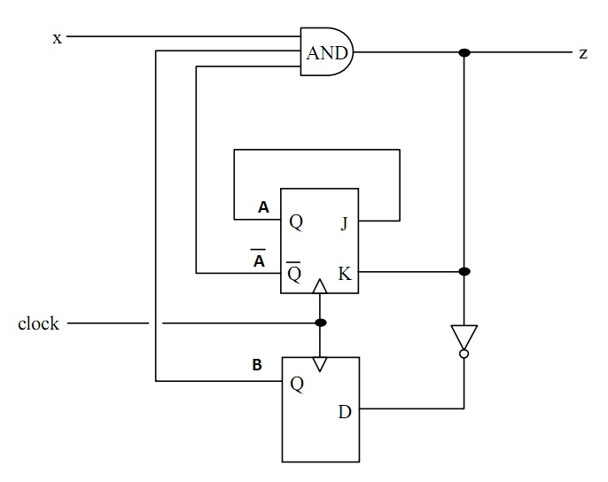

THE END

(25 marks)

Question No. 7

A factory door has 4 possible states, “open”, “opening”, “closed” and “closing”. There is an input to the system, x, which decides transition to next state, that is, if x=0, the door is in the same state as the previous, and if x=1, it transits to the next state. Use logical reasoning to determine the next state for each of the states. The output to the system is y, where y=0 means it is SAFE to use the door and y=1 means DANGER. It is SAFE to use the door when it is open or opening, and the converse when it is closed or closing.

- Using appropriate binary labeling for the states, construct a state diagram and a state table for the above system.
- Design a sequential circuit for the above system using a JK Flip flop and a RS Flip flop.
(10 marks)
Question No. 8

Design an asynchronous decade counter.
(5 marks)

THE END

